Annual Exhibition of Stonemasonry and Stone carving 2022

INVITATION TO EXHIBIT

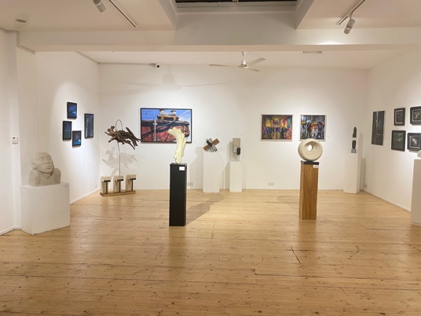
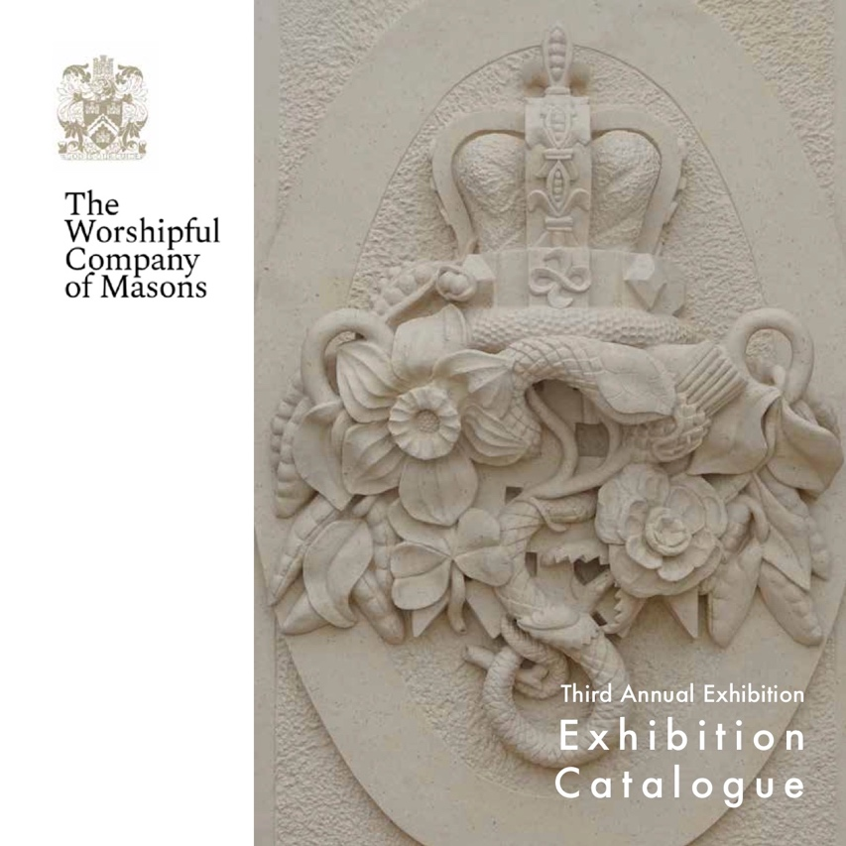

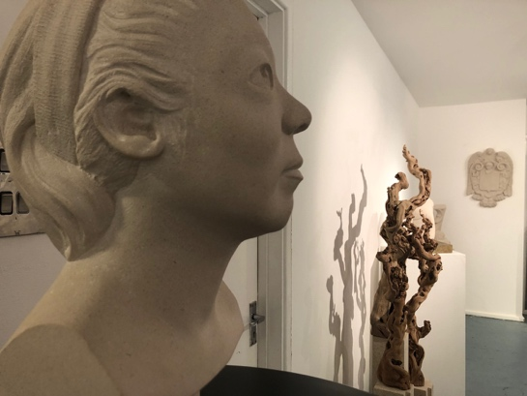

2021 Catalogue cover and Images from the Exhibition

The Fourth edition of The Annual Exhibition will take place at Gallery Different from 14th – 19th November 2022. This year our theme is SCULPTURAL FORM. We will still be accepting submissions of architectural stonemasonry, but would encourage applicants to consider those pieces that express a sculptural form, whether that be figurative or abstract, traditional or contemporary.

The annual exhibition, now a firm fixture in the calendar, showcases works of art created by stonemasons and stone carvers, celebrating their skills and giving a platform for them to offer their work for sale. As in previous years, the Gallery will be waiving the usual gallery commission on sale – allowing this to be passed to the charity, the Worshipful Company of Masons’ Craft Fund which funds the training and subsistence of stonemasons.

If you would like to participate, please complete the following form, submitting up to 3 artworks for consideration. The works must be available for sale. Please read the detailed notes at the end of the submission form which should answer most questions, but if you need further clarification please contact the gallery. If you know of someone who would like to participate – please pass this form to them.

DEADLINES:
Register interest in exhibiting by 30th June 2022;
Submission of up to 3 works by 15th September 2022;
Artists will be notified of artworks accepted for exhibition by 30th September 2022

Artist Submission:

Expression of Interest – please complete this section and return to Gallery Different by 30th June 2022.

Artist Name: |  | Email
DOB |  | Tel No.
Artist Biography – Max 150 words

Artwork Submission:
Please complete and return this form as soon as possible and by 15th September 2022.

First Artwork
Title |  | Dimensions  H x W x D  In cm |  | Weight Est  In kgs
Short
Description
Image Supplied by email  Jpeg | Y/N | Retail Price (price to end customer – leave blank if unsure) |  | Artist Price (min sum you wish to receive)

Second Artwork
Title |  | Dimensions  H x W x D  In cm |  | Weight Est  In kgs
Short
Description
Image Supplied by email  Jpeg | Y/N | Retail Price (price to end customer) |  | Artist Price (min sum you wish to receive)

Third Artwork
Title |  | Dimensions  H x W x D  In cm |  | Weight Est  In kgs
Short
Description
Image Supplied by email  Jpeg | Y/N | Retail Price (price to end customer) |  | Artist Price (min sum you wish to receive)
Any Other Information or comments

Please name the image with your name and the title of the piece and if large please send by WE TRANSFER
Please return this form and images by email to Karina Phillips at info@gallerydifferent.co.uk

EXHIBITION TERMS AND CONDITIONS:

- SET UP: The set up day will be Monday 14th November. Works accepted for exhibition should be delivered to the gallery between 10am and 12 noon as set up will take place during the afternoon. Take down will be Sunday 20th November.

- TRANSPORT – Artists will be responsible to transport their work to the gallery and to collect unsold work at the end of the exhibition. Any works not collected may incur storage charges. The Gallery will liaise with purchasers in relation to delivery and installation of sold works.

- WEIGHT: Please ensure that the work submitted is capable of being handled by two people.

- IMAGES: We will be producing a hard copy catalogue so good images of your work are essential and must be:

- Images must be at least 1 MB and less than 5MB
- Images mut give a clear and uncluttered view of the work
- Images must have your name and the artwork title in the image name

- SALES – all work must be available to purchase.

- PRICING:: –

The Artist price is the minimum amount that you wish to receive on a sale of your work. The retail price (price to the customer) will be comprised of your artist price plus an equal margin. The Gallery will not be taking any commission on sales and the whole of this margin will be donated to the Masons Company Craft Fund, a registered charity.
For example if your Artist price is £500 the retail price would be £1,000 and you would receive £500 and the charity would also receive £500.

- BIOGRAPHY – limited to 150 words, this will be included on your page in the catalogue. Please write in the third person.

- ARTWORK DETAILS – please complete these fully as accurate information is essential for the catalogue and website. For each artwork please ensure that you have given the following information:

Dimensions – height width and depth
Medium – please give an accurate description of the stone, including where relevant its geographical source.
Weight – please give a weight for the work. This can be estimated.
Description – Please give any additional information – eg the inspiration for the work.

- PLACING/HANGING OF THE WORK

If your work is wall hung, then please ensure that there are adequate fixings to the back of the piece to enable it to be safely hung. When delivering please ensure that you have sufficient assistance to be able to carry your work to the designated location within the gallery. This may involve carrying the work down a narrow stairway to the lower ground floor.

